**CHAPTER 2**

**SYSTEM ANALYSIS**

1. **SYSTEM NAME AND BACKGROUND**

**Examination Generating and Automated Examination System of College of Medicine**

The existing system of the College of Medicine in Pamanatasan ng Lungsod ng Maynila in regard of examination system. The system uses scantron machine, it is responsible for checking the exams and the generation of report regarding the examinee ranking and item analysis report. The college of medicine has requested for an examination system that can comply with the specifications they desire.

In process of generating a questionnaire, faculties are asked to generate draft questionnaires to be used for the official questionnaires, as per the request of the chairman. The college of medicine conducts a total of four shifting exam annually. The faculties are tasked to create a questionnaire draft, each draft usually consists of 100-200 questions. Each questions must then be checked whether it existed at a previous existing exam. If it does, the faculty will have to check whether the question is valid.

Inaccurate system analysis report creates a possibility of mistake in evaluating the examinations. A scantron system generates a report after the examination proper that will be evaluated by the chairman, dean, and MEDICS director. They review the results of the examination like the; scores, mean, standard deviation, reliability index and standard error for analysing its efficiency and determine whether the examination satisfies the blueprint’s objective or not. The higher officials usually don’t rely on the results of the item analysis because they prefer the results of the standard method which they will manually do.

Statistical reports are incomplete. The faculty has no basis for validation of the questions for the next examination. After the examination, the scantron will generate the statistical analysis which includes the Discrimination index, Difficulty index and Examinee Ranking. The faculty will distribute the reports for documentation to the Dean, MEDICS director and chairman. The students will also receive theirs scores for them to determine whether they passed or failed. The statistical analysis is only for the benefit of the quality of the next examination.

In accordance to the request of the college of medicine, the researchers are proposing a system that will be able to lessen the time consumption. The program will follow the standard as a basis for the item analysis so that any inaccuracy between the reports generated by the scantron machine and the college standard format/computation will be prevented and that the main basis will be standard. Likewise, we are planning to create a complete statistical report to generate more efficient data computed/consolidated that is helpful for the faculty to analyse and monitor their student’s ranking/performance.

1. **SYSTEM ANALYSIS TOOLS**

**SYSTEM OUTLINE:**

1. **Official Questionnaire**
2. A faculty member will receive the blueprint from the chairman
3. The faculty members will then proceed to create a gather questions that will satisfy the blueprint
4. The draft created by the faculty will be submitted to the chairman for evaluation.
5. After evaluating, the questionnaire will be given to the faculty to be used for the examination proper.
6. **Generating Reports**
7. After examination, the scantron system generates an item analysis report.
8. The scantron system will generate a report of examinee ranking and item analysis.
9. A faculty member prefers to use the standard method than the item analysis generated by the system.
10. Faculty member notices that there’s an inaccuracy between the scantron system and standard.
11. **Completion of Statistical Report**
12. Scantron system generates an item analysis report.
13. The faculty members use the report as a basis reference for future examinations.
14. The faculty figured that the report generated by the scantron system is lacking in information.
15. The faculty members are having difficulty on predicting how many will do well, how many will pass, how many will fail, on the coming examinations.
16. This method is mostly used on Board exams to identify whether a student has a high chance of passing or not.

**SYSTEM FLOWCHART:**

**MAIN FLOW**



**GENERATE QUESTIONNAIRE DRAFT**

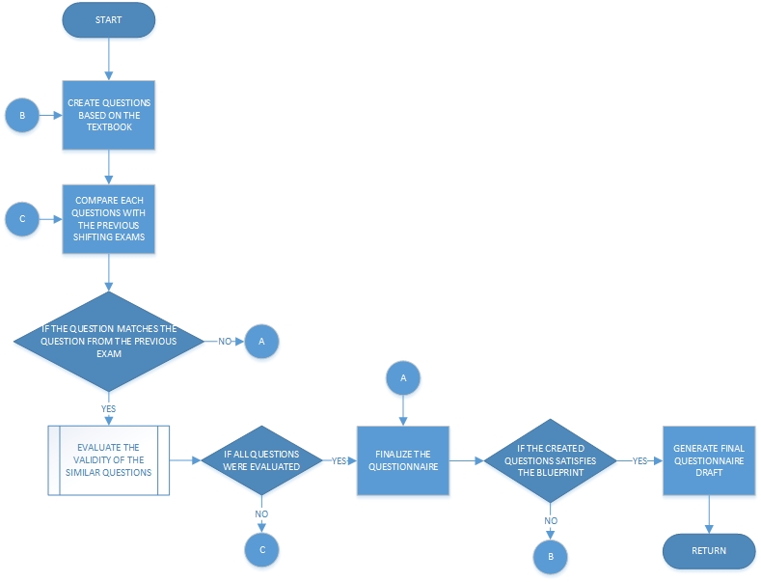

**GENERATE OFFICIAL QUESTIONNAIRE**



**EVALUATE QUESTIONS**



**EVALUATE THE VALIDITY OF THE SAME QUESTIONS**



**GRID CHART:**

|  |  |  |  |  |
| --- | --- | --- | --- | --- |
|  | **Chairman** | **MEDICS** | **Dean** | **Students** |
| Blueprint | 1 | 16 |  |  |
| Questionnaire Draft | 2 |  |  |  |
| Official Questionnaire | 3 | 4 |  | 5 |
| Answer Key | 6 | 7 |  |  |
| Scantron Sheet |  |  |  | 8 |
| Scores | 9 | 10 | 11 | 12 |
| Item Analysis | 13 | 14 | 15 |  |

**CONTEXT DIAGRAM:**

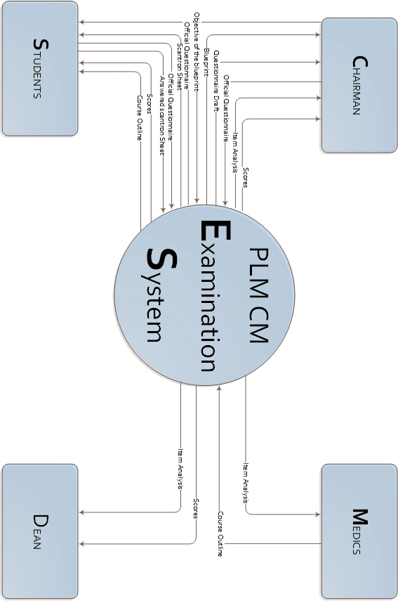

**DATA FLOW DIAGRAM: Level 1**

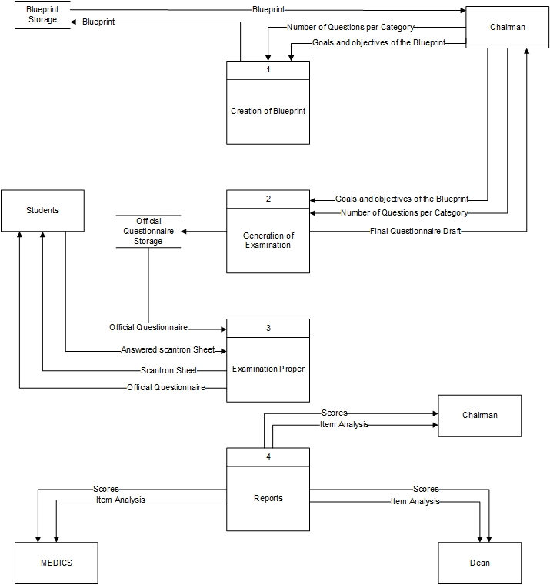

**DATA FLOW DIAGRAM: Level 2**

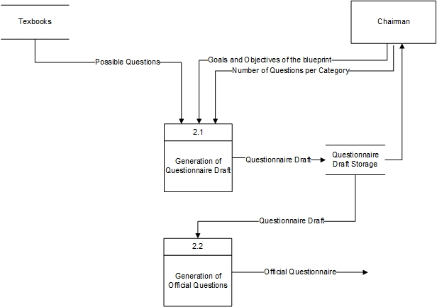

**DATA DICTIONARY:**

**SYLLABUS**

|  |  |  |  |
| --- | --- | --- | --- |
| Field Name | Field type | Length | Description |
| Department | Alphabetic | 50 | College of Medicine Department |
| Course Title | Alphabetic | 30 | Subject Syllabus Title |
| Course Code | Alphanumeric | 10 | Subject Code |
| Course Rationale | Alphabetic | - |  |
| Course Description | Alphabetic | - | Brief description of the subject |
| Credit | Alphanumeric | 10 | Number of units |
| Total number of hours | Alphanumeric | 10 | Total hours per subject |
| Pre-requisites | Alphanumeric | - | Subject cannot be taken after failing the subject |
| Terms | Alphanumeric | 20 | Semester and Year level |
| Faculty Members | Alphabetic | - | Faculty Names |
| Course Objectives | Alphabetic | - | Weekly objectives |
| Specific Objectives | Alphabetic | - | Daily Objectives |

**BLUEPRINT**

|  |  |  |  |
| --- | --- | --- | --- |
| Field Name | Field type | Length | Description |
| Remember | Alphabetic | 30 | Category #1 for Cognitive Processes dimension |
| Understand | Alphabetic | 70 | Category #2 for Cognitive Processes dimension |
| Apply | Alphabetic | 30 | Category #3 for Cognitive Processes dimension |
| Analyze | Alphabetic | 50 | Category #4 for Cognitive Processes dimension |
| Evaluate | Alphabetic | 30 | Category #5 for Cognitive Processes dimension |
| Create | Alphabetic | 30 | Category #6 for Cognitive Processes dimension |
|  |  |  |  |

**QUESTIONNAIRE DRAFT**

|  |  |  |  |
| --- | --- | --- | --- |
| Field Name | Field type | Length | Description |
| Department | Alphabetic | 50 | College of Medicine Department |
| Course Title | Alphabetic | 30 | Subject Title |
| Course Code | Alphanumeric | 10 | Subject Code |
| Exam | Alphanumeric | 30 | Type of Shifting or Comprehensive Examination |
| Deadline | Numeric | 10 | Date of the Last Submission of Draft |
| Question | Alphabetic | 200 | Questions that satisfies the Blueprint |
| Professor Name | Alphabetic | 30 | Professor’s Name |
| Chairman Name | Alphabetic | 30 | Chairman’s Name |
| Date submitted | Alphanumeric | 10 | Date of the Submitted draft |

**OFFICIAL QUESTIONNAIRE**

|  |  |  |  |
| --- | --- | --- | --- |
| Field Name | Field type | Length | Description |
| Department | Alphabetic | 50 | College of Medicine Department |
| Course Title | Alphabetic | 30 | Subject Title |
| Course Code | Alphanumeric | 10 | Subject Code |
| Exam | Alphabetic | 30 | Shifting or Comprehensive Examination |
| Batch | Alphanumeric | 30 | Course, Batch number, type of exam, school year |
| Module | Alphabetic | 30 | Course, Batch number, type of exam, school year |
| Student Name | Alphabetic | 30 | Student’s Name |
| Course | Alphabetic | 10 | Course code |
| Year | Alphanumeric | 3 | Year level |
| Block | Numeric | 1 | Block Section |
| Date | Alphanumeric | 10 | Date of the examination proper |
| Score | Numeric | 3 | Number of Right Answer |
| Question | Alphanumeric | 200 | Questions that passed the evaluation of the chairman |

**EXAMINEE RANKING**

|  |  |  |  |
| --- | --- | --- | --- |
| Field Name | Field type | Length | Description |
| Department | Alphabetic | 50 | College of Medicine Department |
| Batch Title | Alphanumeric | 30 | Course, Batch number, type of exam, school year |
| Batch | Alphanumeric | 30 | Course, Batch number, type of exam, school year |
| Module | Alphanumeric | 30 | Course, Batch number, type of exam, school year |
| Rank | Numeric | 2 | Ranking of scores of the students from highest to lowest |
| Student Name | Alphabetic | 30 | Student’s Name |
| Code | Numeric | 10 | Code of the Scantron Sheet |
| SN | Numeric | 6 | Serial number of the Scantron Sheet |
| Score | Numeric | 3 | Number of Right Answer |
| Grade | Numeric | 3 | Number of Right Answer |
| Date | Alphanumeric | 30 | Day, Date(Month, Day, Year) |

**ITEM ANALYSIS**

|  |  |  |  |
| --- | --- | --- | --- |
| Field Name | Field type | Length | Description |
| Department | Alphabetic | 50 | College of Medicine Department |
| Batch Title | Alphanumeric | 30 | Course, Batch number, type of exam, school year |
| Batch | Alphanumeric | 30 | Course, Batch number, type of exam, school year |
| Module | Alphanumeric | 30 | Course, Batch number, type of exam, school year |
| Item | Numeric | 3 | Question Number |
| Answer | Alphabetic | 1 | Answer key |
| Difficulty | Alphabetic | 20 | Difficulty Status |
| Difficulty index | Numeric | 5 | Difficulty Value |
| Discrimination | Alphabetic | 20 | Discrimination Status |
| Discrimination Index | Numeric | 5 | Discrimination Value |
| Mean (P) | Numeric | 10 | Mean Percentage Value |
| Standard Deviation (P) | Numeric | 10 | Standard Deviation Percentage Value |
| Mean | Numeric | 10 | Mean Value |
| Standard Deviation | Numeric | 10 | Standard Deviation Value |
| Reliability index | Numeric | 10 | Reliability index Value |
| Standard Error | Numeric | 10 | Standard Error Value |
| Date | Alphanumeric | 20 | Day, Date(Month, Day, Year) |

**USER REQUIREMENTS:**

1. Selection of scope for examination

The chairman and faculty will decide for the selection of scope for the examination. In this form the two of them have the access on the system.

1. Generation of exam form

The chairman has the only access on this part, he/she is the one who will decide on what are the questions will be included on the official questionnaire.

1. Item analysis

It determines the discrimination and difficulty index of a question item.

1. Statistical analysis

It creates the general information needed for the monitoring of college progress, competitiveness and medical student performance.

1. Question management

The user, is allowed to add, delete, rephrase or revise the questions. Depending on how the question index varies.

1. History Report

This report must have a bank of previous examinations